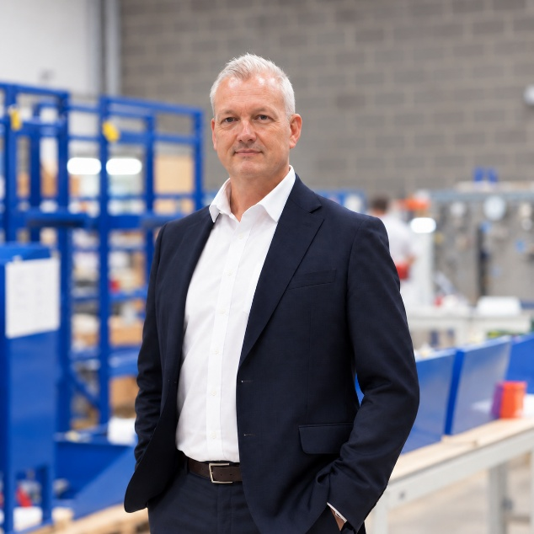

Ben Mellick is Managing Director of AMS Nuclear Engineering, a Somerset-based SME specialising in electrical, control and instrumentation engineering for the nuclear sector.
A Mechanical Engineering graduate with a Master’s degree, Ben has worked with the nuclear industry throughout much of his career. His earlier career included the development, qualification and supply of process control instrumentation for nuclear facilities around the world, before moving into the leadership of an engineering business focused exclusively on the sector.
Ben has led AMS for almost a decade, during which time the business has broadened from its established position supporting the UK’s existing nuclear generation fleet into nuclear new build and other emerging areas of the sector. He has led the company’s development within the Hinkley Point C supply chain, progressing from Tier 2 delivery to becoming a direct Tier 1 supplier.
Through that journey, Ben has developed first-hand experience of both the opportunities and challenges facing specialist SMEs seeking to grow within the nuclear industry, including developing organisational capability, meeting increasingly demanding assurance requirements, building and retaining specialist skills and forming effective partnerships with larger organisations.
He is particularly interested in how the South West can retain and build upon the capability developed through Hinkley Point C, and how proven regional businesses can contribute more effectively across future nuclear programmes. As a member of the Nuclear South West Board, Ben brings the perspective of a regional engineering SME that has grown with the sector, together with a strong interest in helping businesses across the region collaborate, develop capability and access the opportunities created by the next generation of UK nuclear projects.

