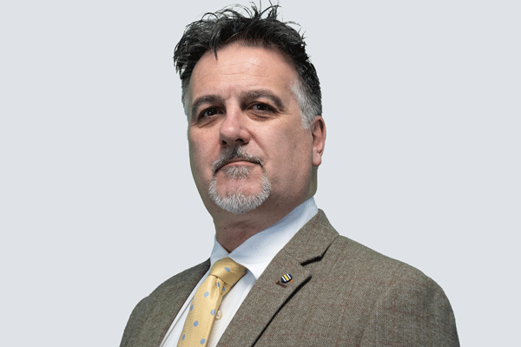
Stefan is a recognised leader in the UK nuclear industry with over 30 years of engineering and commercial experience. He brings a wealth of knowledge to identifying and developing new business opportunities across the nuclear lifecycle – from new-build to decommissioning.
His experience spans corporate international business development, major account management, and project direction and execution. He excels at building relationships with stakeholders, including government agencies, clients, and industry partners.
Stefan is passionate about innovation and developing new technologies within the nuclear sector.
Highlights of Experience:
- Proven track record of driving commercial growth and securing new business opportunities.
- Extensive experience in leading and delivering complex infrastructure projects.
- Strong understanding of the technical, commercial, and regulatory aspects of nuclear projects.
- Champion of innovation and development within the nuclear sector.
Stefan's expertise, experience, and commitment to excellence make him a true leader in the UK nuclear industry. He is dedicated to driving growth, fostering collaboration, and shaping the future of the nuclear sector.
Currently leading the expansion of Turnbull Infrastructure and Utilities into a multi-site nuclear new build business, Stefan previously lead the development and expansion of Framatome UK for 4 years after completing the Project Direction, from inception to year 1, of the National College for Nuclear – the fundamental training location for the UK’s future nuclear technical workforce.

