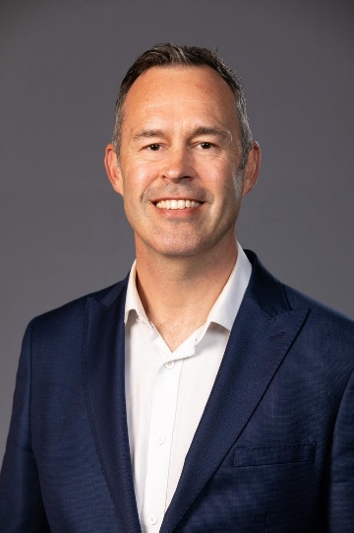
Professor Tom Scott is one of the UK’s most respected nuclear academics, bringing over 20 years of experience across civil and defence nuclear technologies, nuclear safety, emergency response and advanced materials research. He is the Director and founder of the South West Nuclear Hub and holds a Royal Academy of Engineering Professorial Chair at the University of Bristol, co-sponsored by the UK Atomic Energy Authority. He also leads the University’s Interface Analysis Centre, a specialist group of around 80 researchers focused on nuclear-related science and engineering .
Tom has played a significant national role in shaping the UK’s nuclear research and innovation landscape. He has previously served on the Nuclear Innovation and Research Advisory Board (NIRAB) and is a current member of the Ministry of Defence’s Nuclear Research Advisory Council (NRAC) . His expertise has informed government policy, major programme delivery and long-term capability planning across the sector.
A strategic thinker with a strong operational track record, Tom has spent the past 15 years working at the intersection of technology, geopolitics and national energy strategy. His roles have required “big picture strategic thinking” and the ability to plan and execute complex teaching, research and expansion strategies across large teams and multi-million-pound portfolios. He routinely collaborates with local and central government, as well as international partners including the IAEA, US National Laboratories, CNL and JAEA.
Tom has chaired and contributed to numerous strategic alliances and advisory boards, including partnerships with AWE, EDF Energy and Sellafield Ltd. His leadership in establishing the South West Nuclear Hub is widely recognised as evidence of his ability to build collaborative, high-impact structures that strengthen regional capability and national resilience.
Tom brings to the Nuclear South West Board a rare combination of academic depth, strategic foresight and practical experience in delivering major research and technology programmes. His understanding of the UK’s nuclear infrastructure needs, combined with his commitment to the South West’s role in national energy security, makes him a powerful advocate for the region at a pivotal moment for the sector.

