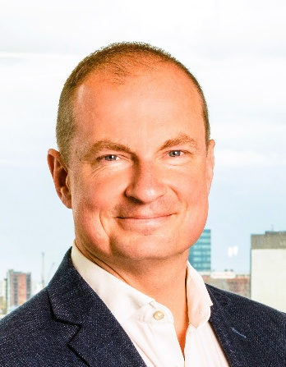

Matt is a Chartered Engineer with both the IMechE and the IMarEST and is a Fellow of the Chartered Management Institute. He has spent his career working across the nuclear industry at home and abroad and is currently PwC UK’s Lead Nuclear Director.

With a background that includes both engineering and professional services, Matt has led, delivered and advised complex strategic change and performance improvement programmes, major capital projects and demanding operational initiatives domestically and internationally. His early career was spent in the Royal Navy Submarine Service; and with both Atkins and PwC, he has helped to drive multi-£Bn strategic growth.

As the founding Chair of Nuclear South West, Matt is delighted to re-join the Board as the UK again gears up for large scale investment in nuclear (both from the civil nuclear energy or defence nuclear interests).

Matt lives in Bristol with his family and in his spare time, he enjoys surfing, cycling and supporting his local community.

Nuclear South West – Why it Matters

NSW was set up to help the region access the huge opportunities in nuclear that were catalysed by HPC. The founding principles were that we could help the South West UK attract external investment (into what was then >£50Bn of infrastructure opportunity) and that the legacy of HPC through the work of NSW could establish a strong foundation for export, across the UK and internationally. Now, as we look ahead to fuel load and operations in HPC; an increased regional decommissioning portfolio; the opportunity to develop Oldbury as a site for SMR deployment; and the infrastructure developments in Devonport we have another, refreshed opportunity to support the region. And having lived and worked in the South West for most of my life I am delighted to have been asked to help NSW shape this next chapter.

