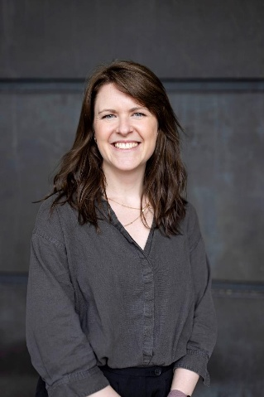
Anna Tyler-Revell brings 15 years of experience across nuclear decommissioning, organisational development and large-scale change programmes to the Nuclear South West Board. Her career has been shaped by a deep commitment to people, skills and culture, and to ensuring that the nuclear sector continues to attract, develop and retain the talent it needs for the future.
Anna currently serves as Head of Organisational Development at Nuclear Restoration Services Ltd (part of the NDA group), where she leads a broad portfolio spanning skills, early careers, leadership development, talent management, culture, and organisational transformation. Her work focuses on building the capability and confidence of the workforce, strengthening leadership pipelines, and creating collaborative, positive working environments across complex, highly regulated programmes.
Throughout her career, Anna has worked across projects, programmes and change initiatives, helping organisations navigate transition, embed new ways of working and develop the people strategies required to deliver long-term success. She is known for her ability to bring teams together, champion inclusive culture, and design practical, people-centred solutions that support both organisational performance and individual growth.
Having made the South West her home 15 years ago, Anna is passionate about the region’s potential, particularly its ability to lead the UK in developing the next generation of nuclear skills. Her role on the Nuclear South West Board reflects her commitment to ensuring that the region’s workforce is ready for the opportunities ahead, from decommissioning and new build to advanced technologies and future skills needs.

